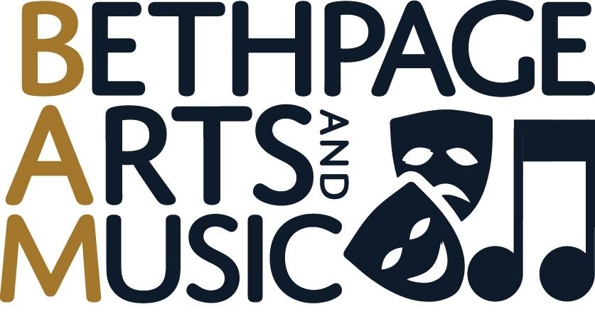
Please lend your voice and energy, and join BAM – your support will help us keep music and theatrical arts alive in our schools and give back to our students with scholarships, music festivals, performances and so much more.

For questions or more info, e-mail us at bpagemusic@gmail.com
Membership in BAM is $12 per family
Tear off this section & return it to your school with a check made payable to BAM
FAMILY NAME:
CHILD’S NAME(S) AND SCHOOL:

